CONSOLIDATED EXAM QUESTIONS
INTERMOLECULAR FORCES AND GASES
Contents
CONSOLIDATED EXAM QUESTIONS INTERMOLECULAR FORCES AND GASES 1
Syllabus 2
SHAPES OF MOLECULES (VSEPR LEWIS/DOT DIAGRAMS/POLAR AND NON POLAR COVALENT) – 12.1, 12.2 3
2017 S1 3
2017 S2 3
2020 S1 3
2020 S2 3
2023 S1 6
2023 S2 7
INTERMOLECULAR FORCES – 12.3 9
2017 S1 2017 S2 9
2020 S2 12
2023 S1 2023 S2 14
CHROMATOGRAPHY – 13.1-13.2 17
2017 S1 17
2017 S2 17
2020 S1 2020 S2 18
2023 S1 2023 S2 21
PROPERTIES OF GASES AND KINETIC THEORY – 14.1-14.2 25
2017 S1 25
2017 S2 25
2020 S1 26
2020 S2 26
2023 S1 26
2023 S2 26
CALCULATIONS INVOLVING GASES – 14.3 27
2017 S1 27
2017 S2 27
2020 S1 30
2020 S2 30
2023 S1 34
2023 S2 34

Syllabus

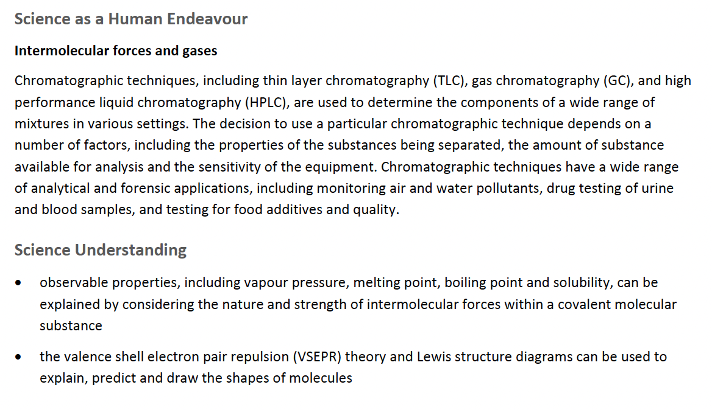
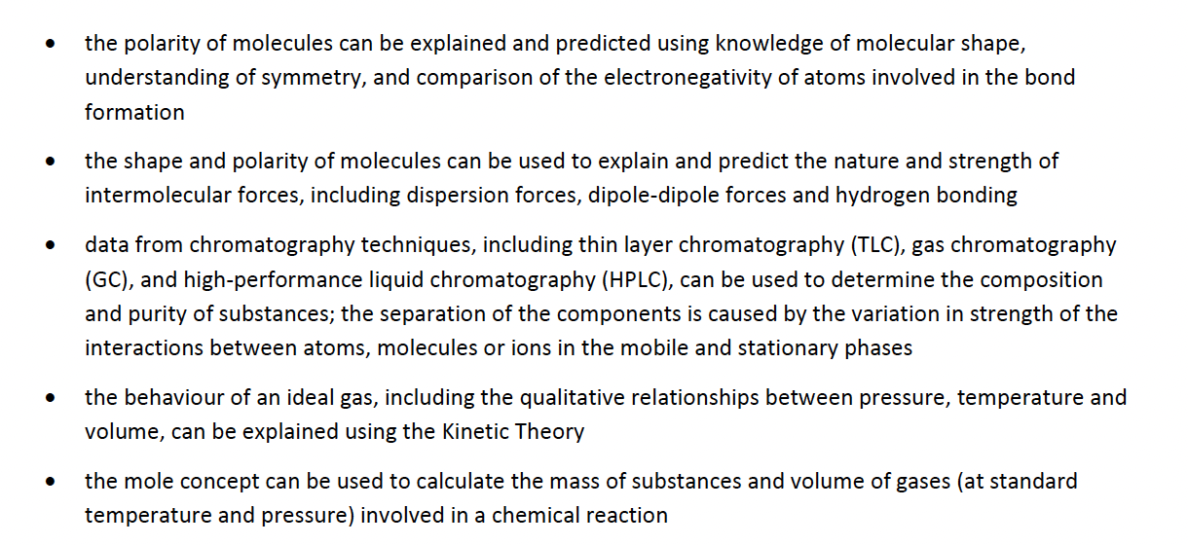

SHAPES OF MOLECULES (VSEPR LEWIS/DOT DIAGRAMS/POLAR AND NON POLAR COVALENT) – 12.1, 12.2

2017 S1

2017 S2

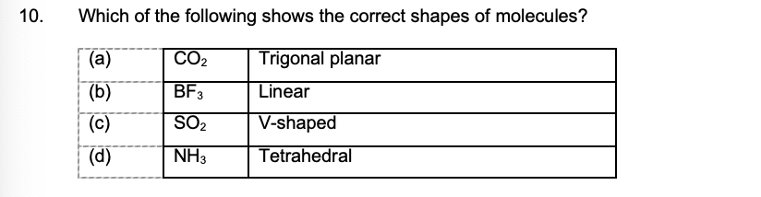

2020 S1

2020 S2

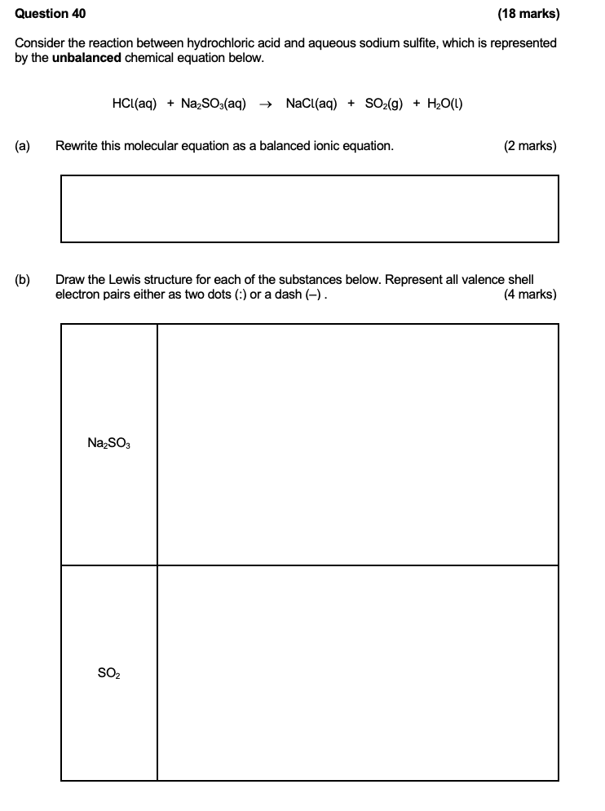
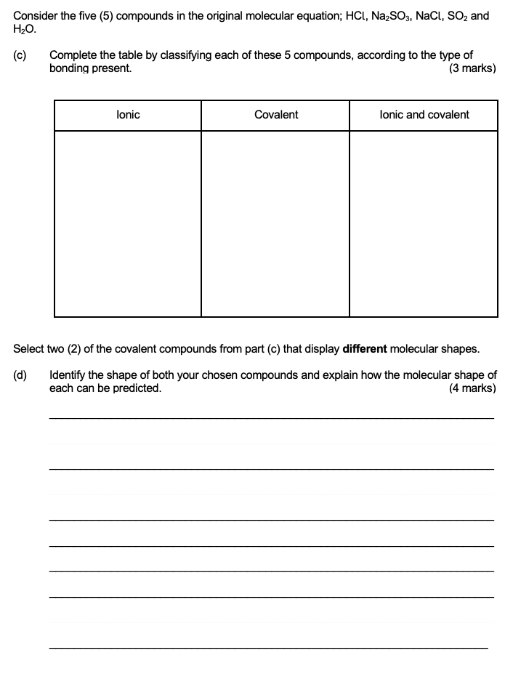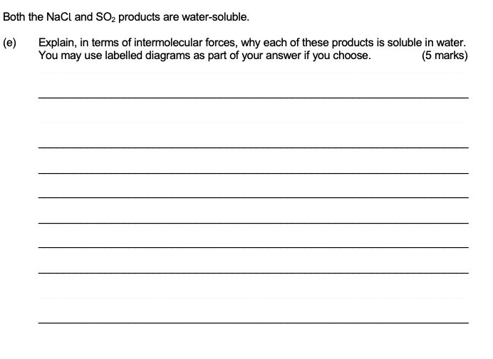

2023 S1

2023 S2

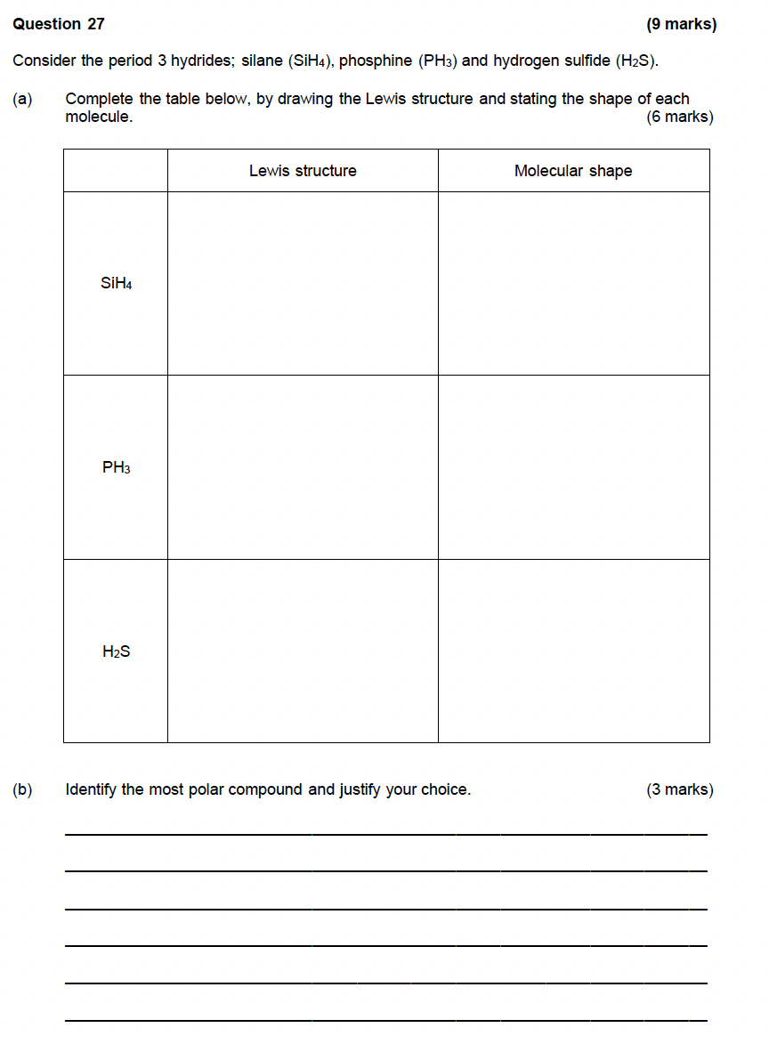
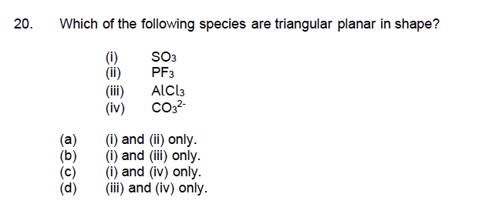

INTERMOLECULAR FORCES – 12.3

2017 S1
2017 S2
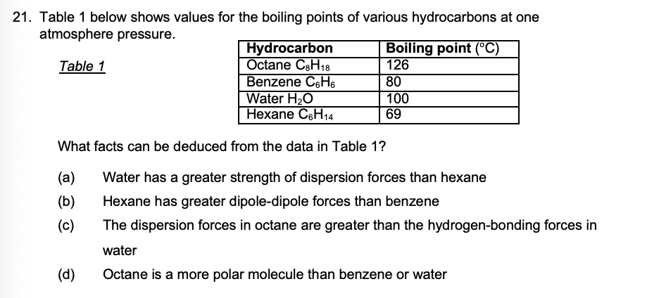
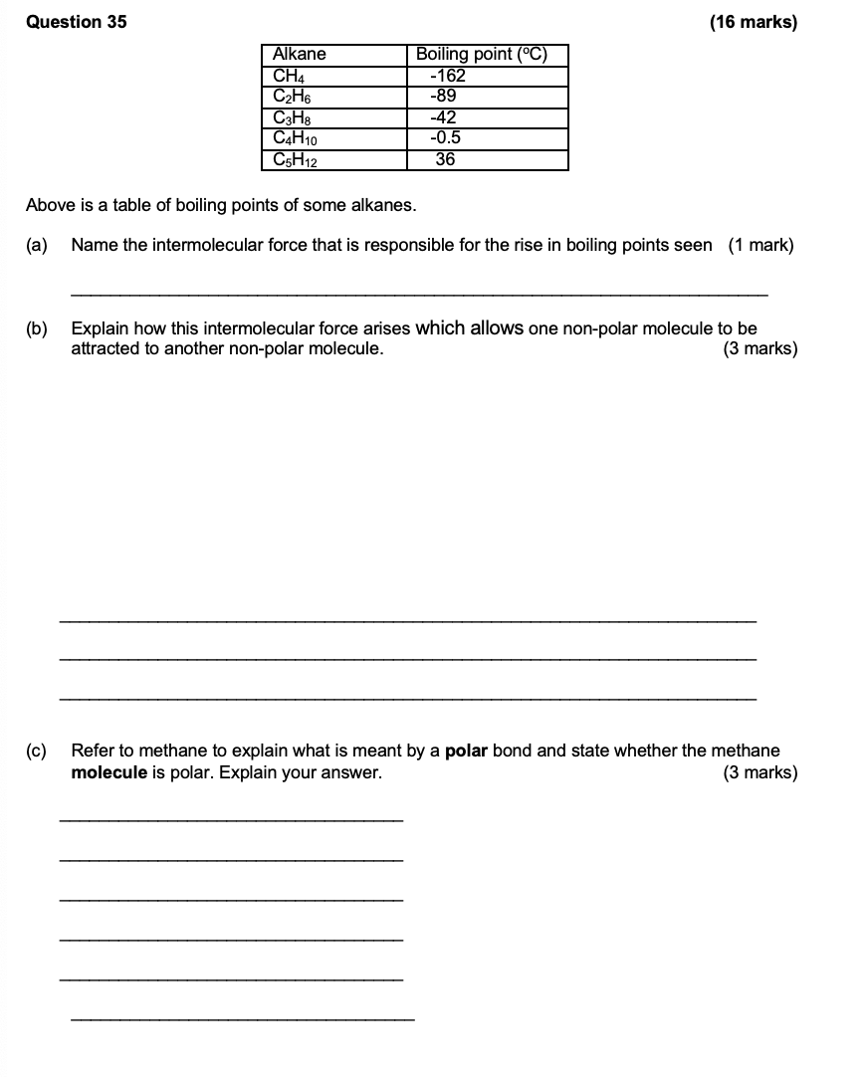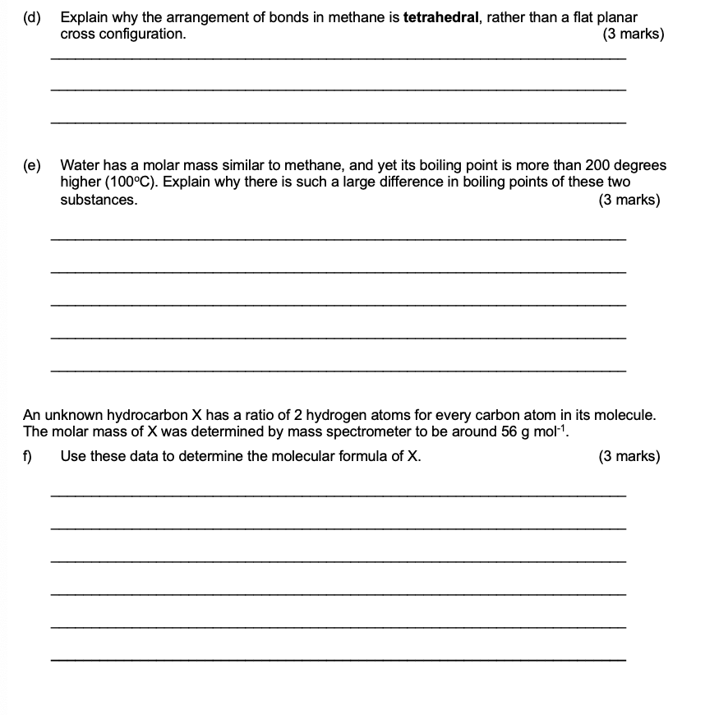

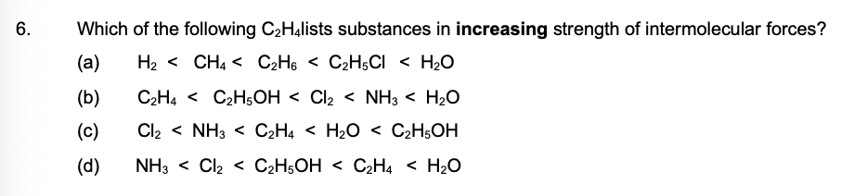
2020 S1

2020 S2
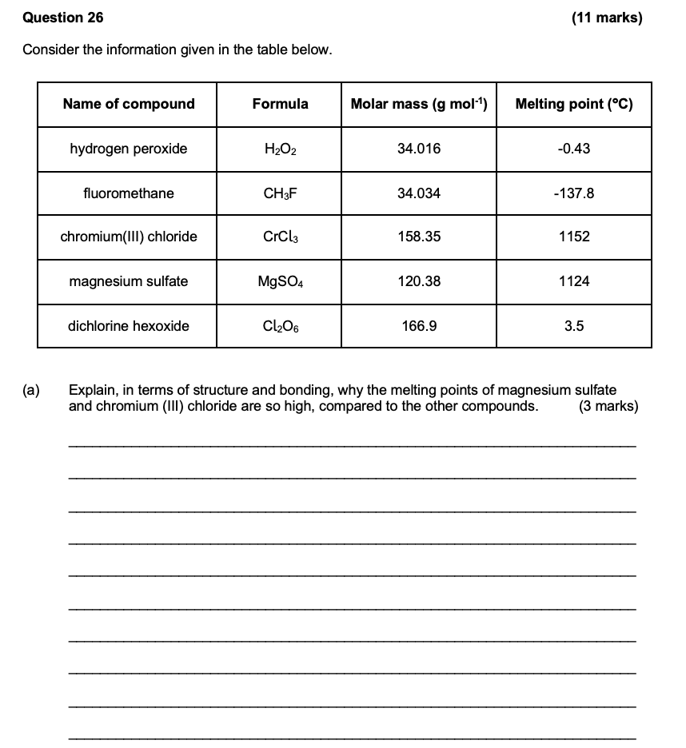
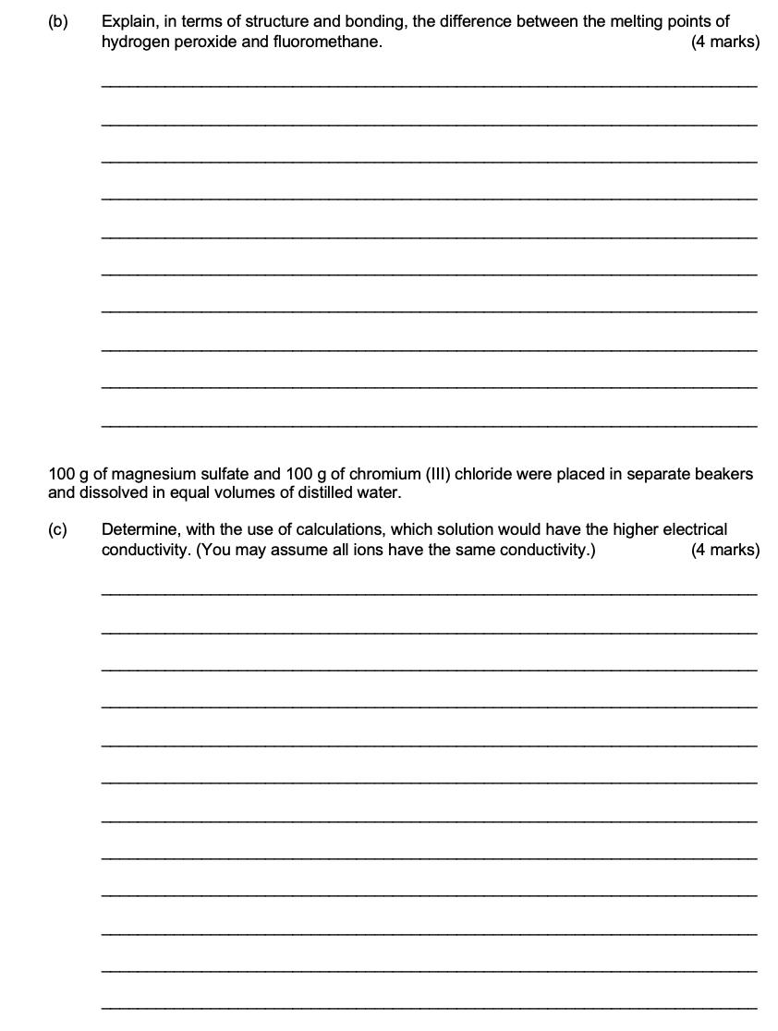

2023 S1
2023 S2
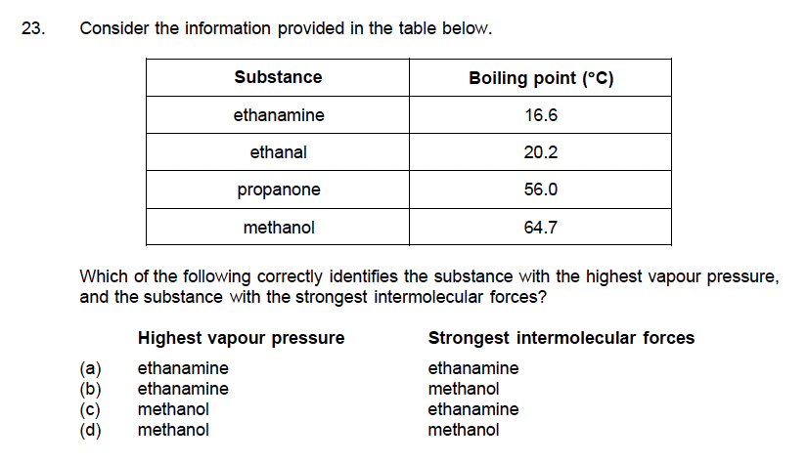
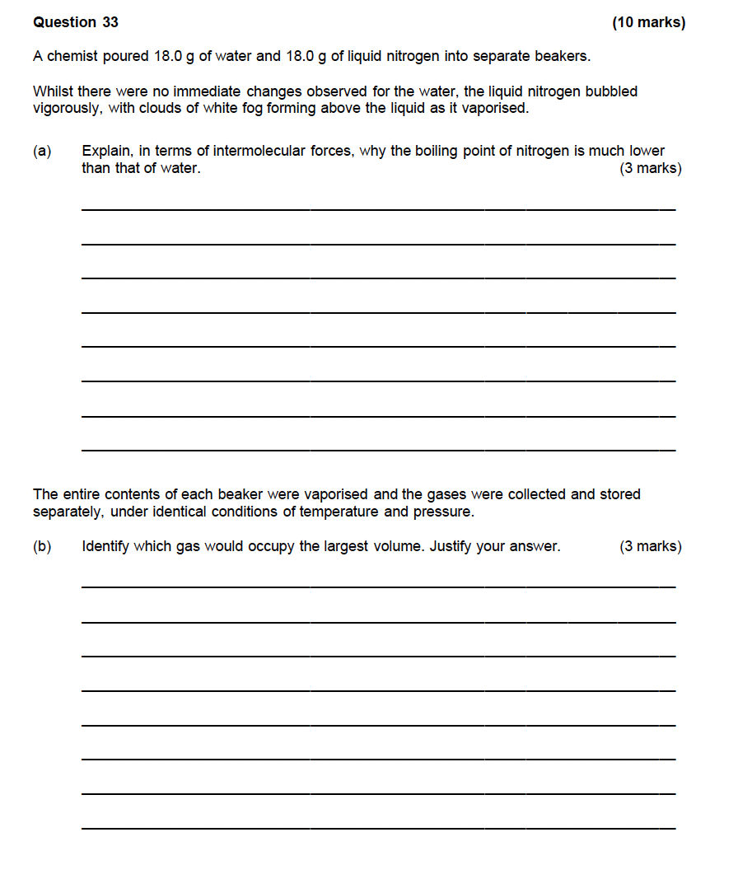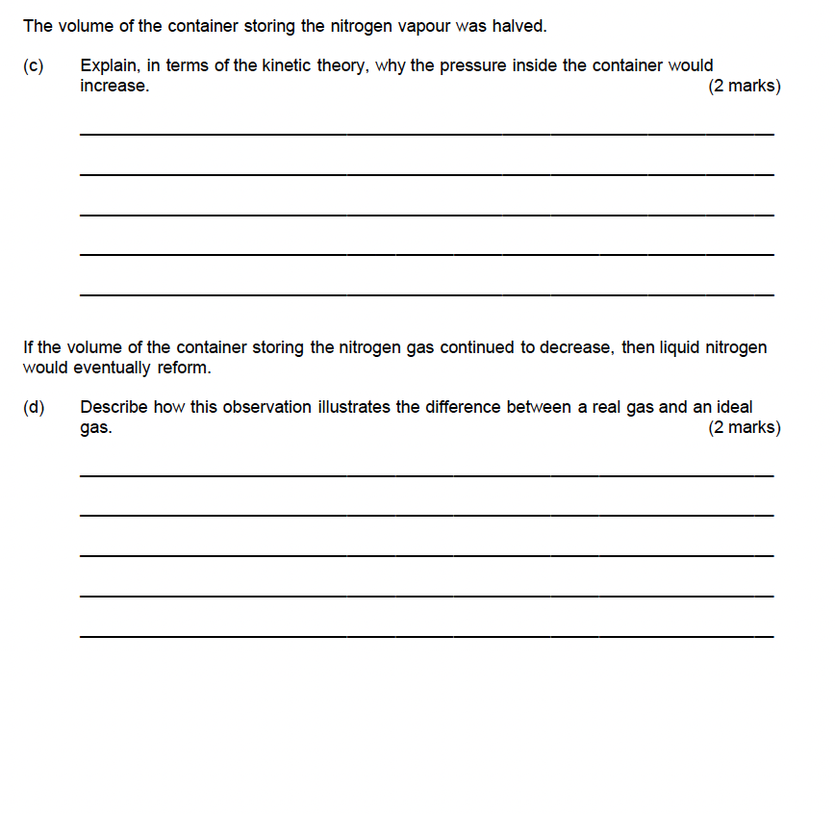

CHROMATOGRAPHY – 13.1-13.2

2017 S1

2017 S2
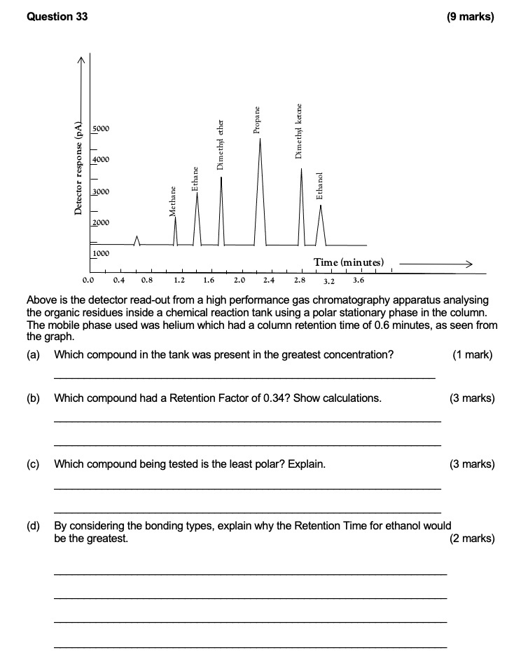

2020 S1
2020 S2
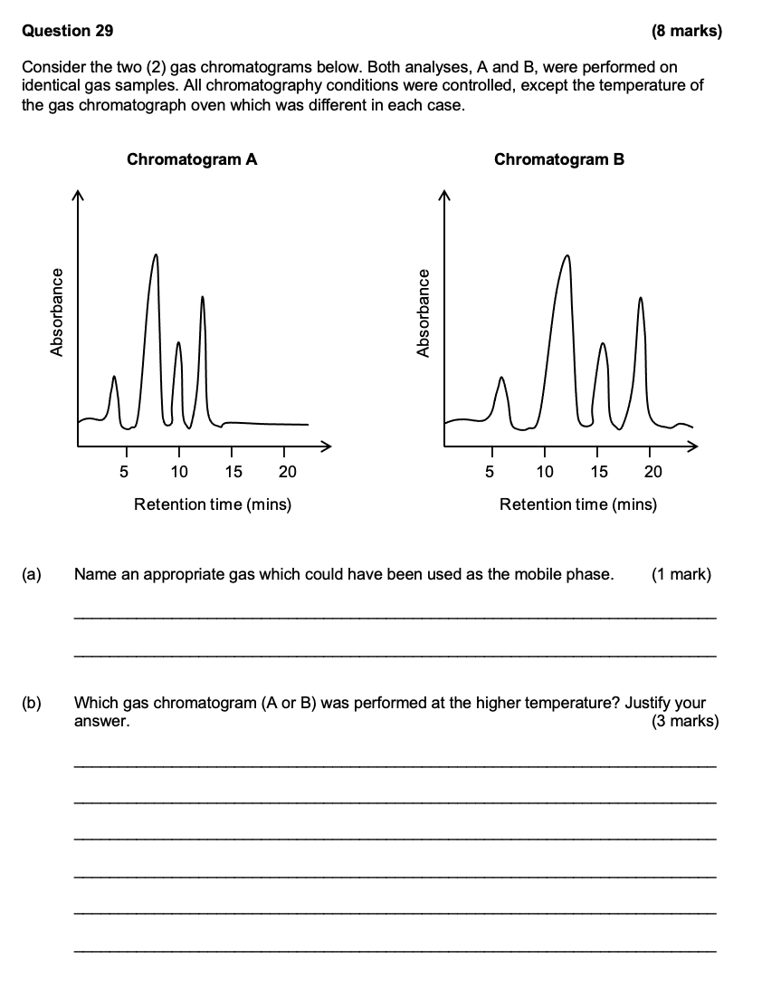
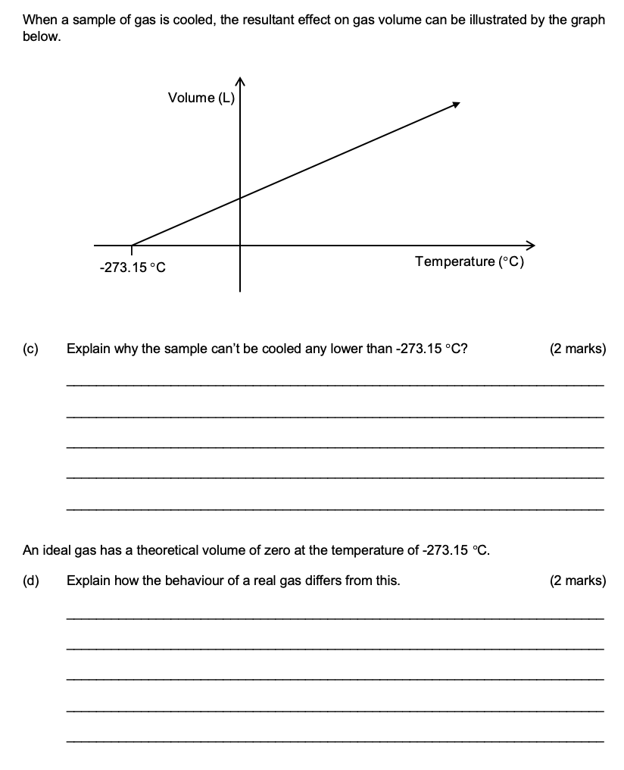
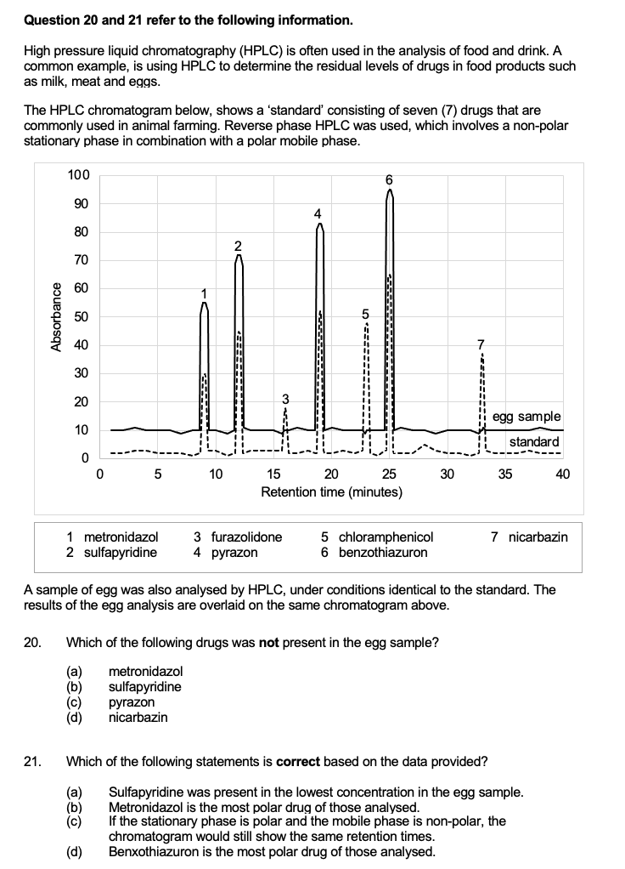

2023 S1
2023 S2
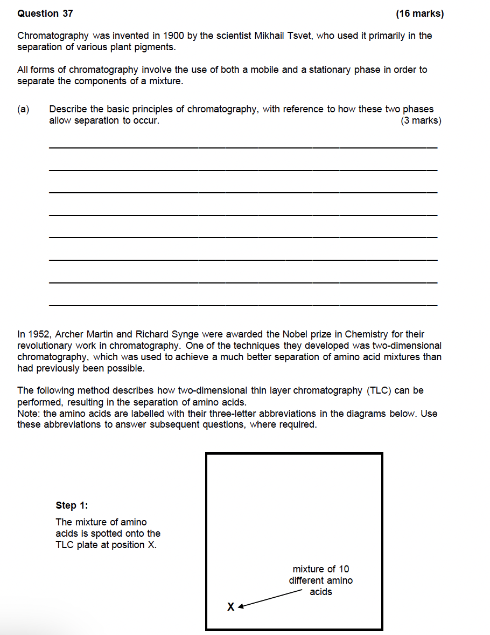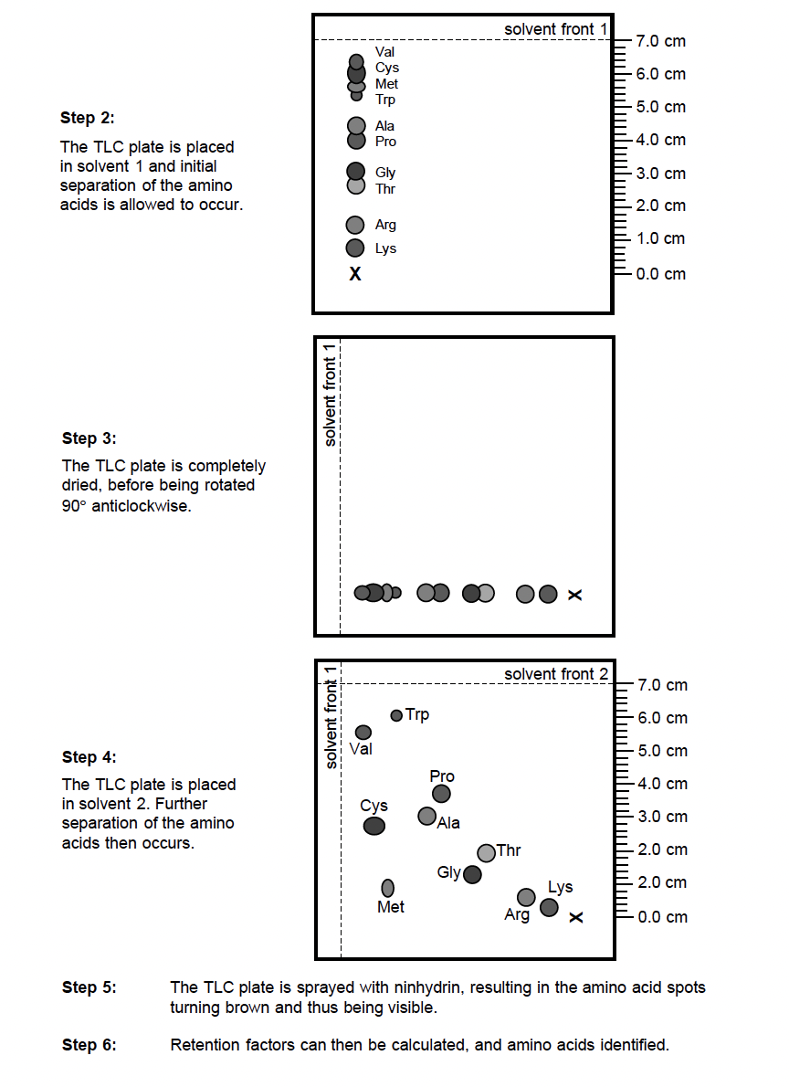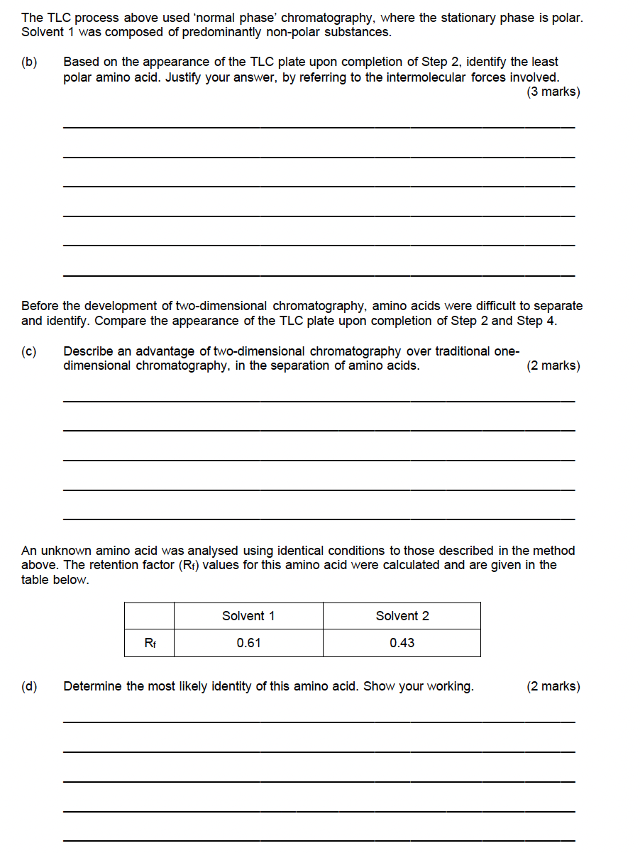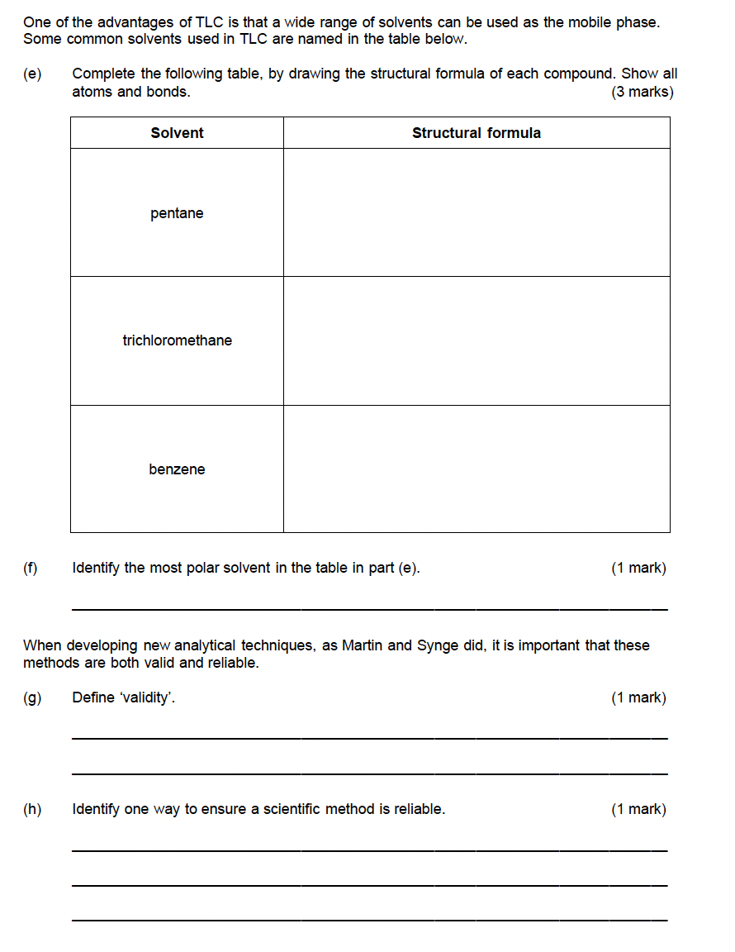

PROPERTIES OF GASES AND KINETIC THEORY – 14.1-14.2

2017 S1

2017 S2
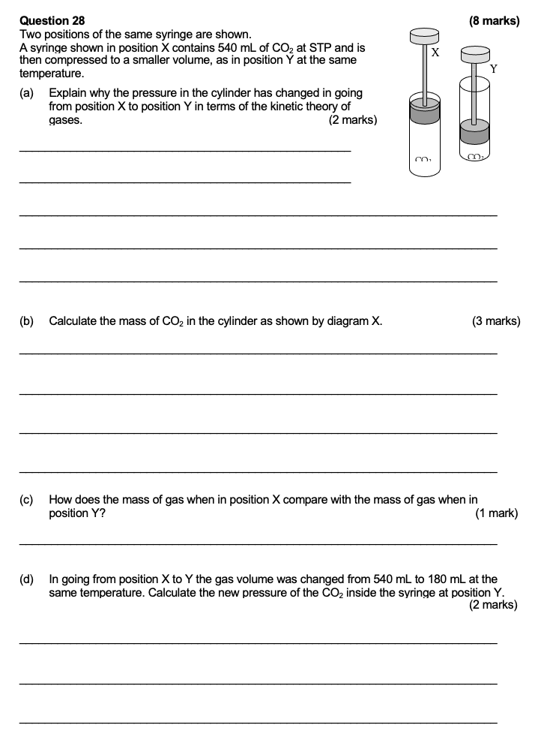

2020 S1

2020 S2
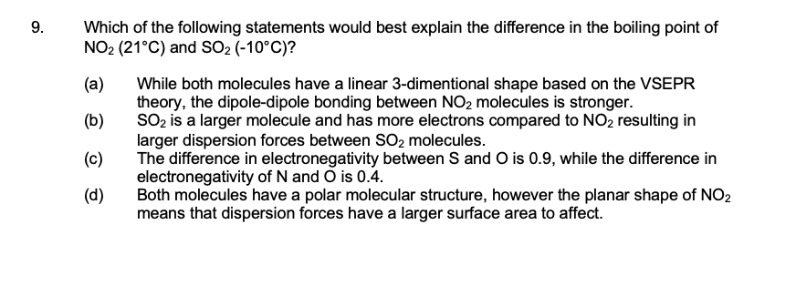

2023 S1

2023 S2

CALCULATIONS INVOLVING GASES – 14.3

2017 S1

2017 S2
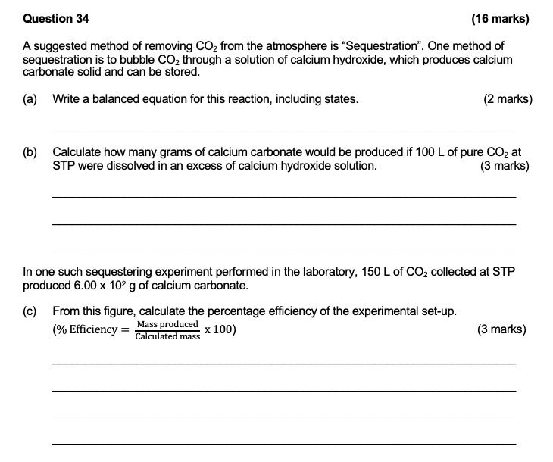
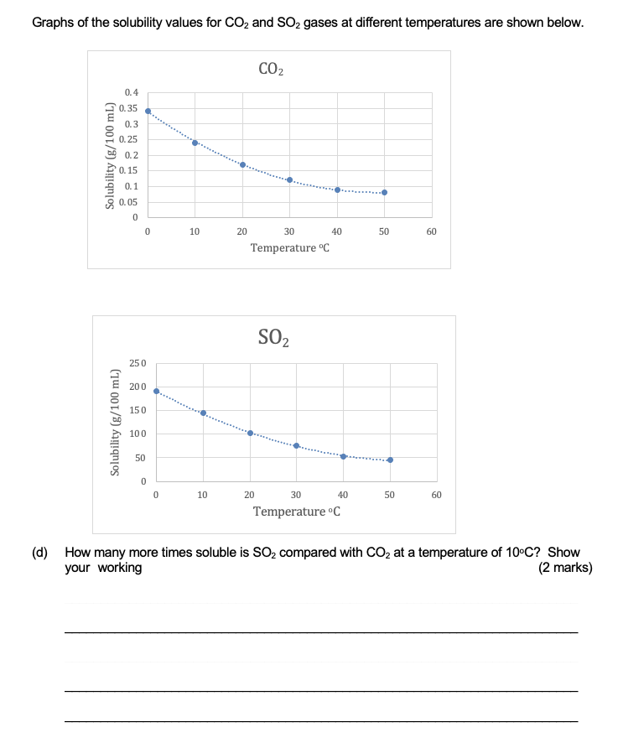
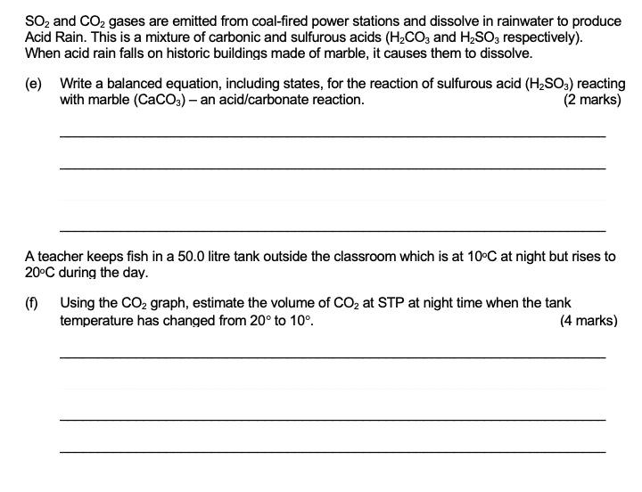
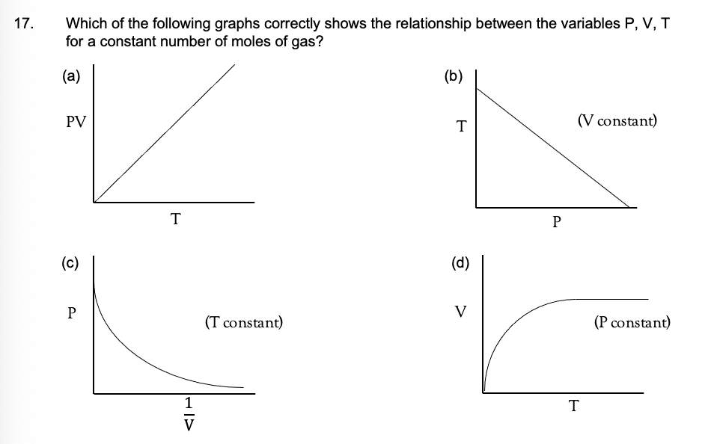

2020 S1

2020 S2
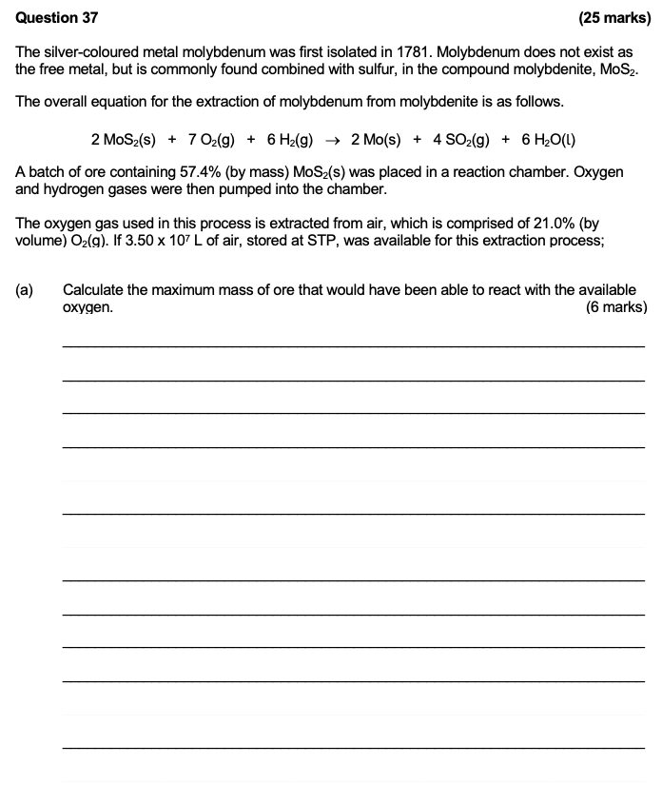
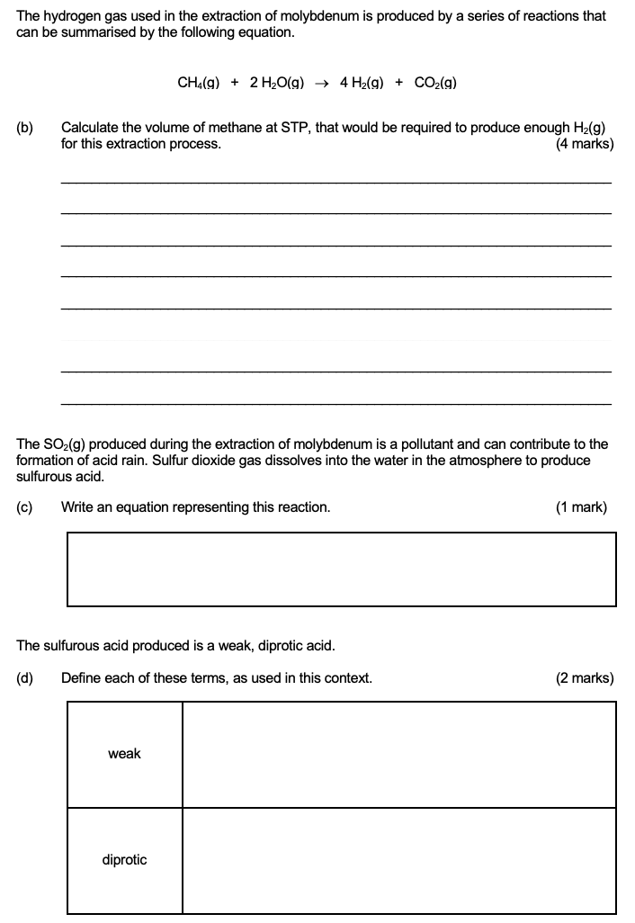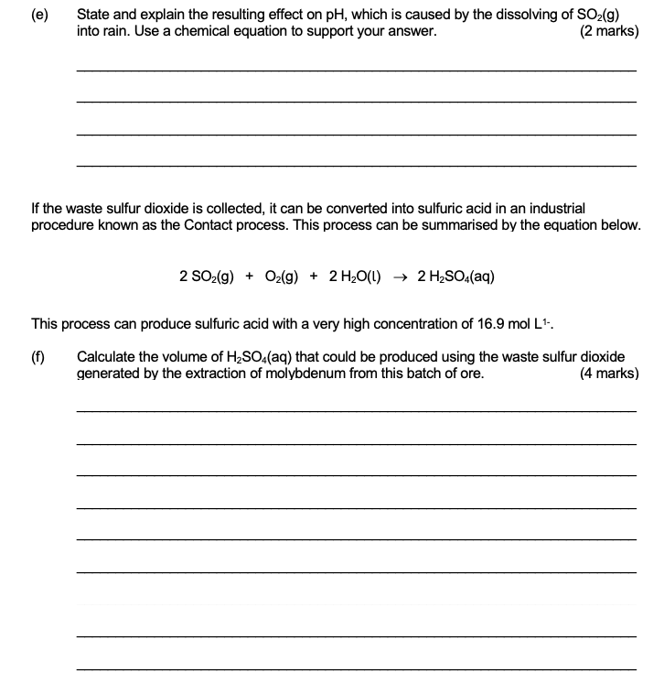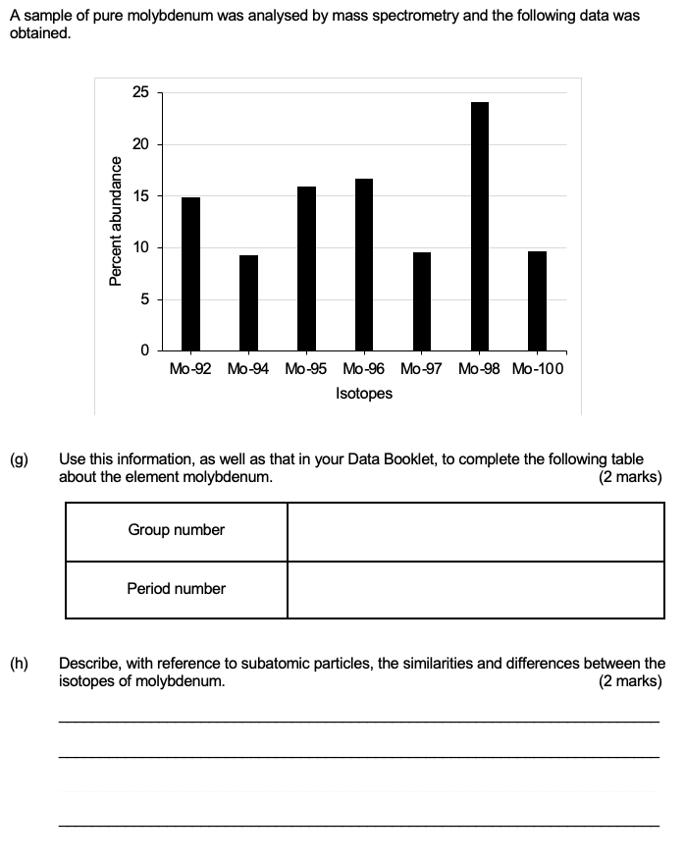

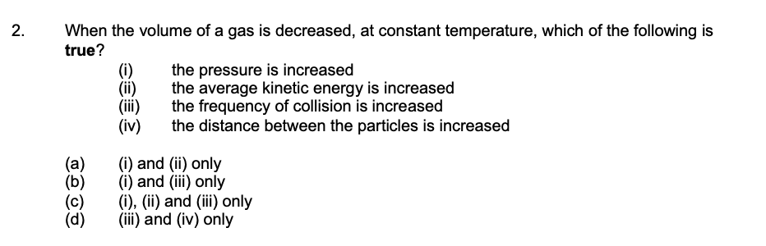

2023 S1

2023 S2

